BUILD AN EVENT MANAGEMENT SYSTEM USING SALESFORCE

**INTRODUCTION**

* 1. **Overview**

An Event Management System provides campus event planners a flexible, fully integrated solution to simplify the event management process and keep your customers, faculty and students happy, while maintaining important reports and data for making real estate and future planning decisions.

* 1. **Purpose**

A custom event management application in Salesforce can make managing events a lot easier. We’ve seen clients struggle with challenges in four main areas.

**Logistics —**From security to catering to facilities staff, there are many moving parts that need to align, and they’re usually time-sensitive. Plus, you may have a range of equipment coming into the space, from technical and A/V components to industrial kitchen tools and catering appliances.

**Communication —**communications serve as the foundation of your entire event. Every event organizer’s worst nightmare is running an event where no one shows up. Every event organizer’s second-worst nightmare is running an event where a group of people get the wrong message and forget to show up / show up at the wrong time / go to the wrong place, etc. But with so many stakeholders, from staff to speakers to attendees, event communications are often more complicated than sending out the occasional email.

**Marketing —**Most event organizers don’t have a native place for event listings, so they use third-party platforms like Eventbrite or Splash or Eventzilla. These platforms are all perfectly decent, but they don’t allow for much customization. What if your event requires attendees to apply and be accepted only after their application is reviewed? What if you want to feature your logo or other partner logos prominently on the event listing? Marketing an event is more challenging when you’re unhappy with your customization capabilities.

**Personalization —**Every business is unique. You probably want to see your events info in the context of your leads, contacts, opportunities, etc. which means you’ll need to integrate any event management apps you use with your database. In doing so you might run into compatibility issues, certain apps might not be available in Salesforce’s AppExchange, or you might not have the resources on your team to build a custom integration if it’s needed.

**PROBLEM DEFINITION & DESIGN THINKING**

**2.1 Empathy Map**

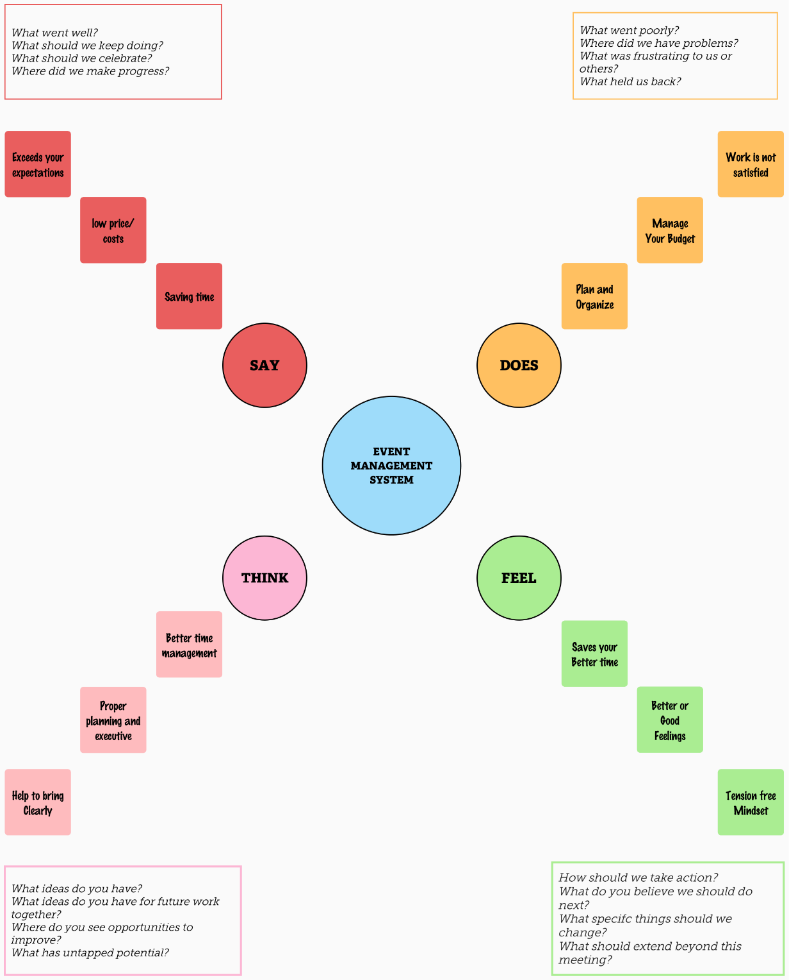

**2.2 Ideation & Brainstorming Map**

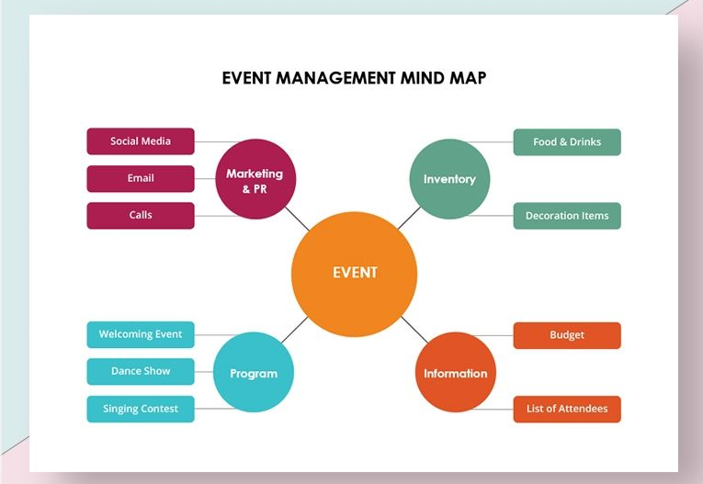

**RESULT**

* 1. **Data Model**

|  |  |
| --- | --- |
| **OBJECT NAME** | **FIELDS IN THE OBJECT** |
| Event | |  |  | | --- | --- | | Field Label | Data Type | | City | Text Area | | Date/Time | Start Date | | Event Name | Master-Detail Relationship | |
| Attendees | |  |  | | --- | --- | | Field Label | Data Type | | Id | Auto Number | | Phone | Phone | | Email | Email | | Tickets | Picklist | |
| Speakers | |  |  | | --- | --- | | Field Label | Data Type | | Bio | Text Area | | Email | Email | | Event Name | Look-Up Relationship | |
| Vendors | |  |  | | --- | --- | | Field Label | Data Type | | Email | Email | | Phone | Phone | | Service Provider | Text | | Event Name | Look-Up Relationship | |

* 1. **Activity & Screenshot**

1. **Salesforce**

Home page

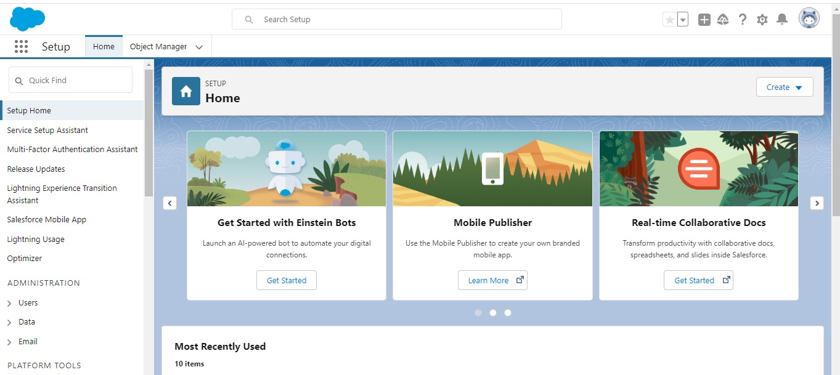

1. **Objects**

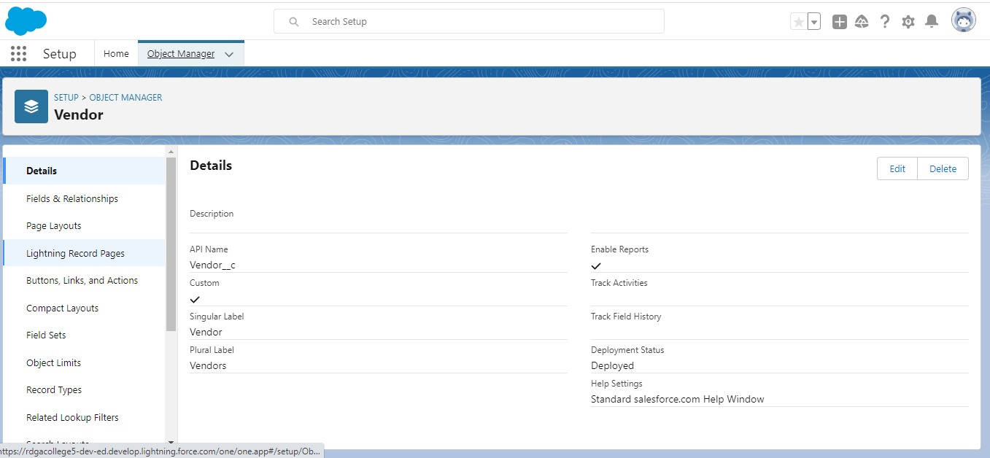

1. **Tab**

Custom Tabs

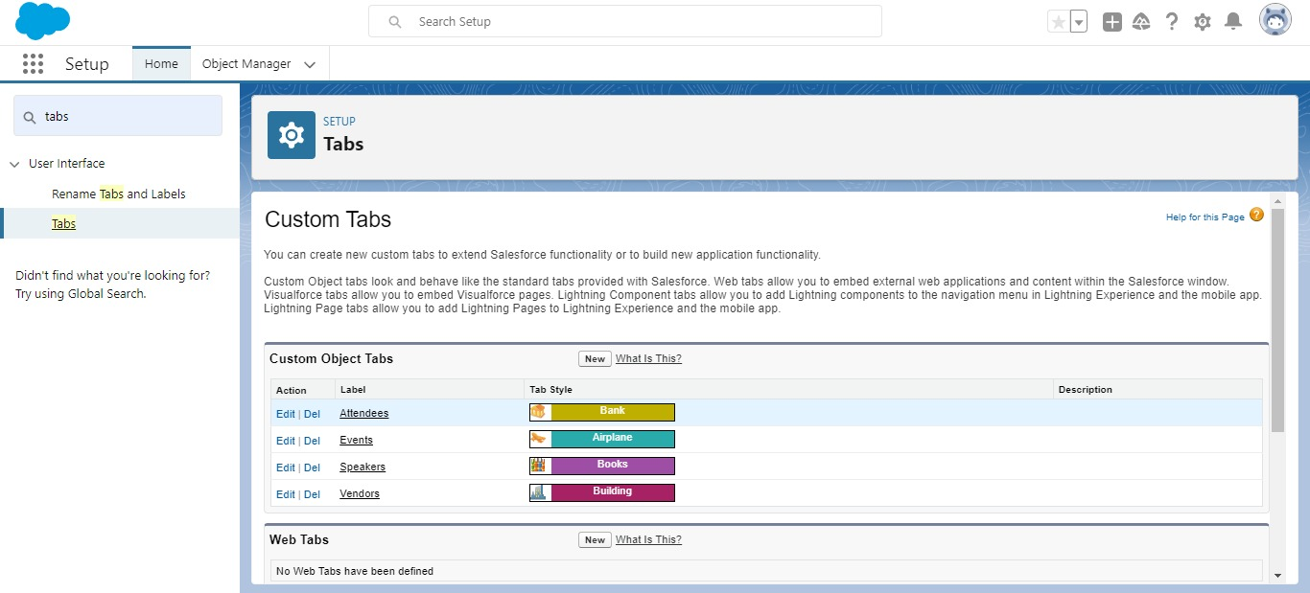

Application

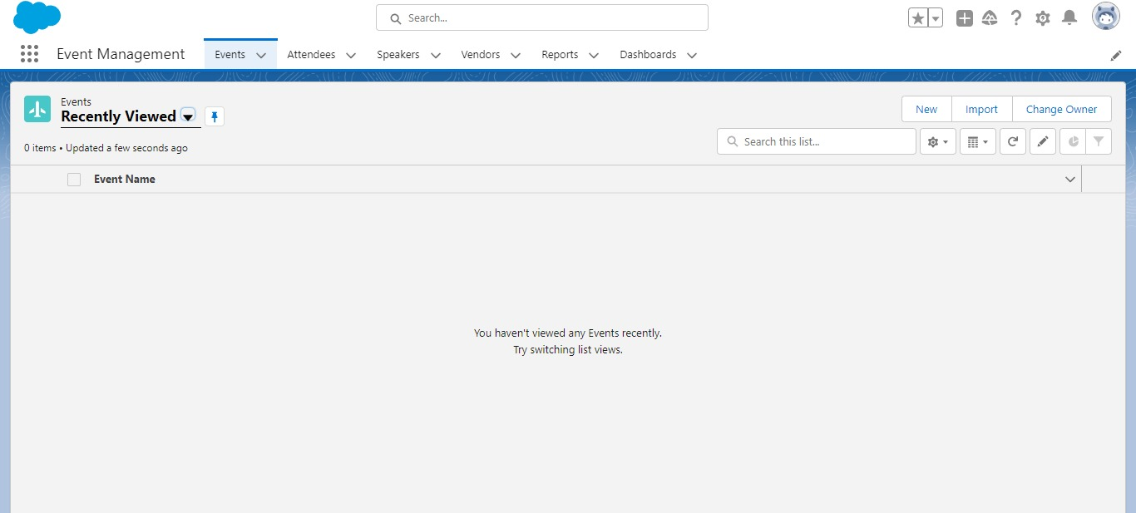

1. **Fields**

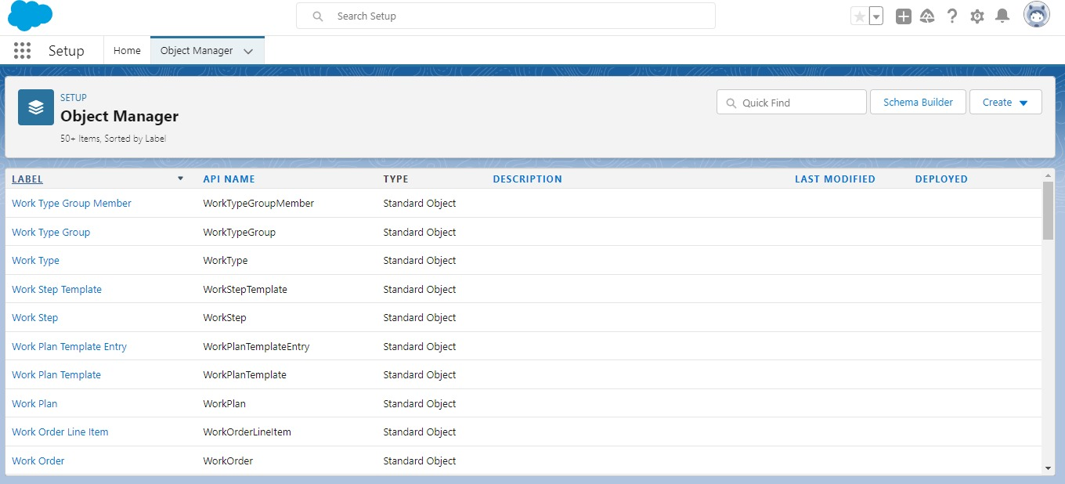

1. **Profile**

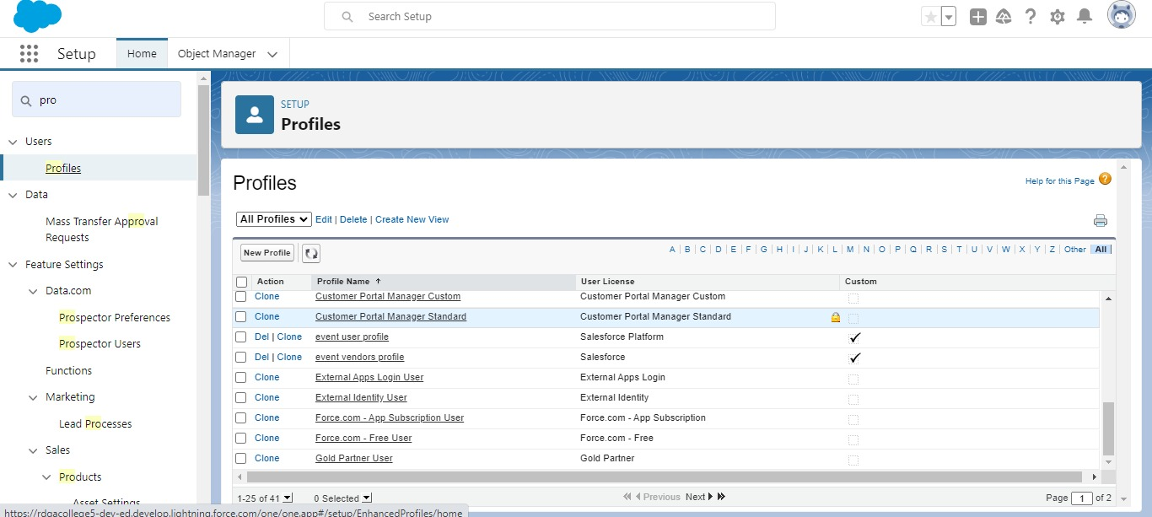

1. **User**

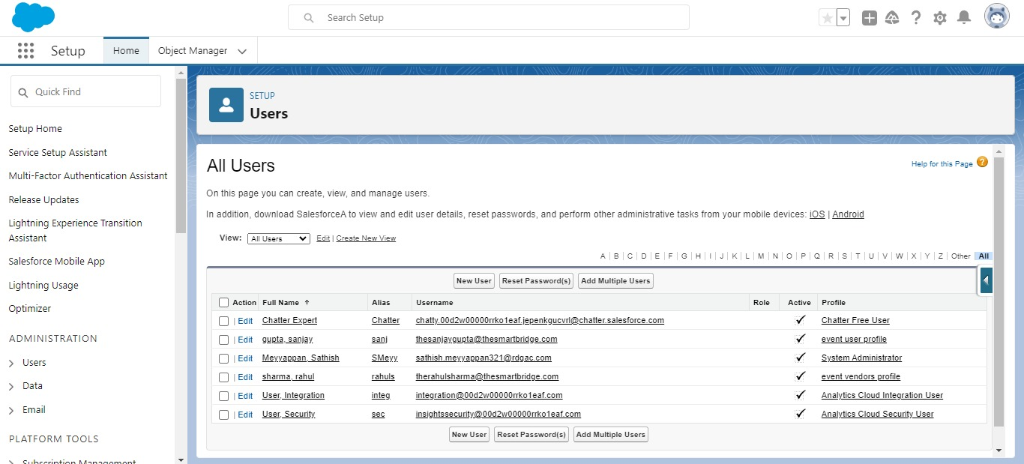

1. **Permission sets**

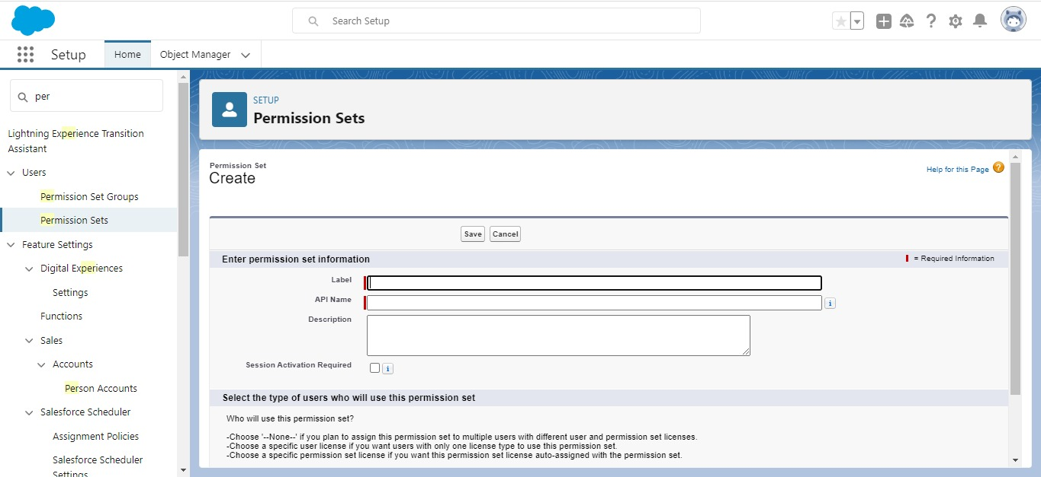

1. **Reports**

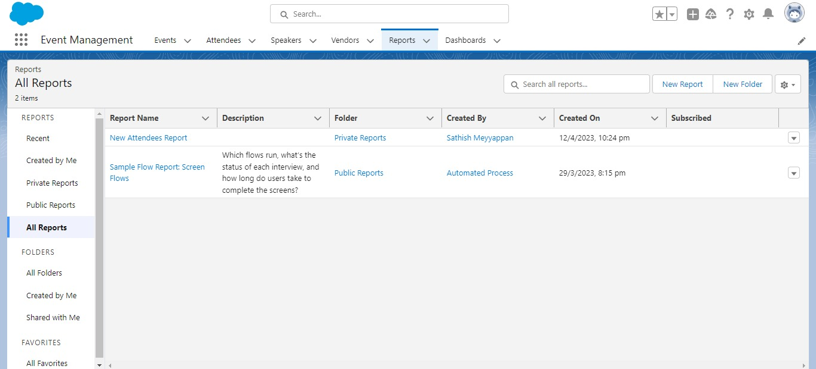

**Trailhead Profile Public URL**

**Team Lead** - [**https://trailblazer.me/id/sathishrdm**](https://trailblazer.me/id/sathishrdm)

**Team Member 1** - <https://trailblazer.me/id/vallarasurdm>

**Team Member 2** - <https://trailblazer.me/id/anbarasanrdm>

**Team Member 3 -** <https://trailblazer.me/id/ranjanirdm>

**Team Member 4 -** <https://trailblazer.me/id/bharathirdm>

**ADVANTAGES**

* Easier event management. A dedicated event platform makes the entire event easier to manage.
* Saves time.
* Cut costs.
* Increase engagement.
* Analyze and improve.
* Automate your event.
* Display a greater level of professionalism.
* Take a holistic approach to event management.

**DISADVANTAGES**

* Unconventional work hours.
* Time away from family and friends.
* Experience requirements.
* Job instability.
* Multiple events at the same time.
* High level of responsibility.

**APPLICATIONS**

* An Event Management System (or Event Management Software) helps organizers plan, execute and report on events, driving success for their business.

**CONCLUSION**

* Event Management System is user friendly and cost effective system, it is customized with activities related to event management life-cycle. It provides a new edge to management industry.
* Solution Dot always keep your objectives and goals on top priority while developing any plan of work.

**FUTURE SCOPE**

* The scope of event management as a career in India is immense. This career provides a unique opportunity to rephrase our social beliefs.
* Hosting events can redesign the structure of a city by facilitating economic growth, employment opportunities, urban development, and promoting indigenous culture and heritage.